### **SOLAR POWER EQUIPMENT LEASE**

Between

LA RINCONADA COUNTRY CLUB (LESSEE)

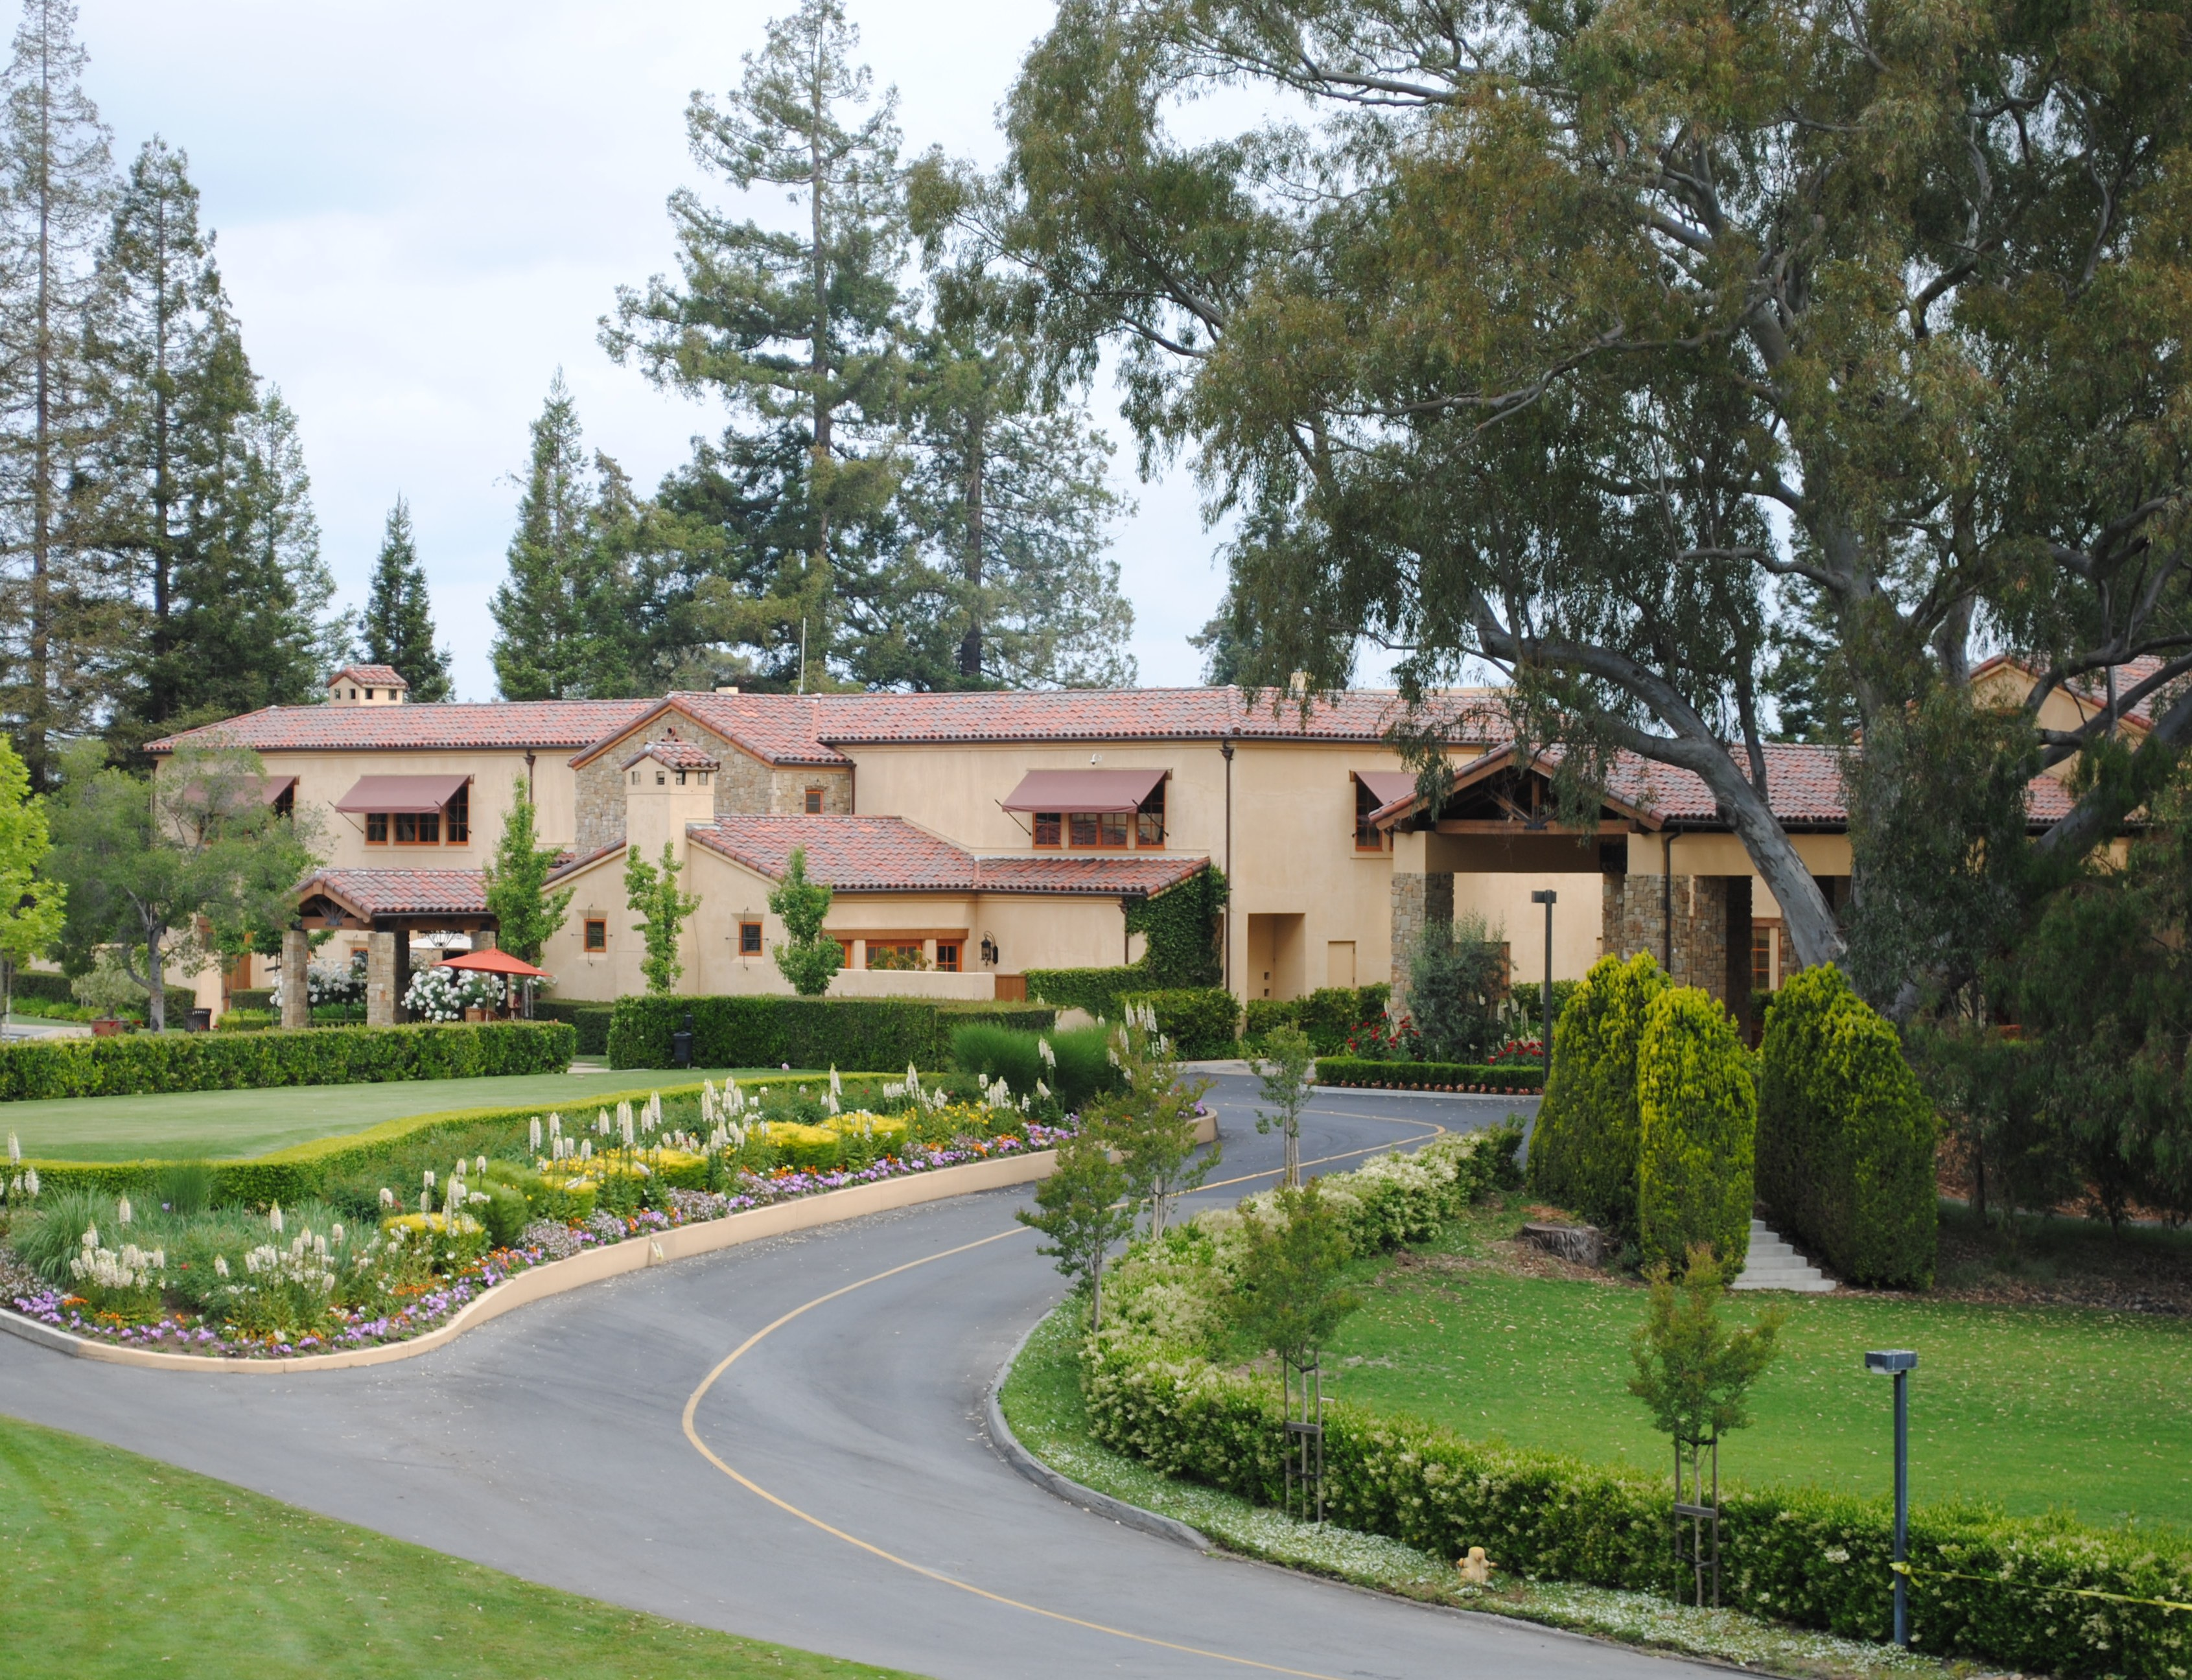

**AND**

**ALTERNATIVE ENERGY COUNTRY CLUB**

**SOLAR SOLUTIONS, LLC (LESSOR)**

Table of Contents

**SOLAR POWER EQUIPMENT LEASE** 1

1.1 LEASING: 1

2. RENT, TERM AND PAYMENT 2

2.1 Rent 2

2.2 Term 2

2.3 Payment 2

2.4 Estimated Taxes 3

2.5 Purchase Options 3

2.6 Method of Payment. 3

3. LESSOR’S CONDITIONS PRIOR TO INSTALLATION AND CHANGES 3

3.1 Preconditions for Installation. 3

3.2 precondition 3

1.3. Prior Approval of System Design 4

3.4 Right to Cancel Lease Due to Significant Change from Initial Estimates 4

4. LESSORS CONDITIONS DURING INSTALLATION AND TERM 4

4.1 Excluded Work 4

4.2 Incentive Documentation; Permits 5

4.3 Waste Materials 5

4.4 Cancellation Due to Delay 5

4.4 Installer 6

4.5 No Side Agreements 6

5. LESSEE’S SOLAR SYSTEM OBLIGATIONS 6

5.1 General Obligations 6

5.1.1 to notify Lessor immediately if any part of the Solar System is stolen or damaged, or if any other emergency situation exists regarding the Solar System; 6

5.1.2 to notify Lessor within 24 hours if, in the opinion of the Lessee, the electronic monitor is not working properly or that the Solar System is otherwise not working properly; 6

5.1.3 to allow the Solar System to be moved, removed, or repaired only according to the Limited Warranty, and to cooperate with those repairs; 6

5.1.4 to not take any action or do anything to the Solar System that invalidates or voids the Limited Warranty; 6

5.1.5 not to change or remove the tags or markings on the Solar System; 6

5.1.6 not to do anything to Lessee’s Property that would shade the Solar System and to trim trees, shrubs, and other vegetation that would shade the Solar System; 6

5.1.7 not to take any action or do anything to the Property or allow any condition that results in the Solar System failing to perform as originally as described in Exhibit C or in the Solar System no longer being connected to the local utility; 6

5.1.8 to provide a safe work area at the Property for installing and maintaining the Solar System; and 6

5.2 Access Rights 7

5.3 Preservation of Ownership Rights 7

5.4 Monitor; Net Metering Service 7

5.5 Photos 7

6. OWNERSHIP OF SOLAR SYSTEM AND ELECTRICITY 7

6.1 Ownership of Solar System 7

6.2 Loss or Damage to Solar System 8

6.3 Ownership of Electricity; Additional Electricity 8

7. OWNERSHIP OF ENVIRONMENTAL ATTRIBUTES AND INCENTIVES 8

7.1 Environmental Attributes 8

7.2 Incentives 8

7.3 Rights in Incentives 8

7.3 Claims and Representations 9

7.4 Transfer of Solar System Equipment during Lease Term. 9

7.5 EXCEPT AS PROVIDED ABOVE IN THIS SECTION 7, LESSEE SHALL NOT SELL, PLEDGE, ASSIGN, SUBLEASE, OR TRANSFER THE RIGHTS OR OBLIGATIONS UNDER THIS LEASE OR THE INTEREST IN THE SOLAR SYSTEM WITHOUT THE PRIOR WRITTEN CONSENT OF LESSOR, WHICH WE MAY WITHHOLD IN OUR SOLE DISCRETION. 9

8. END OF THE TERM 9

8.1 Renewing this Lease 9

8.2 Ownership Transfer 9

8.3 sold or transferred 10

8.4 purchase 10

8.5 Deployment 10

8.6 Repossession of Equipment. 10

8.6.1 if Lessee are not in default under this Lease at the end of the Term and Lessor requests to remove the Solar System, then Lessor will remove the Solar System at no cost to Lessee with Lessee being responsible for any property restoration; 10

8.6.2 if Lessee is in default under this Lease at the end of the Term and Lessor requests to remove the Solar System, then Lessee will pay for the removal the Solar System; or 10

8.6.3 if Lessee is not in default under this Lease at the end of the Term and Lessor has not requested to remove the Solar System, then Lessee may request in writing that Lessor remove the Solar System at no cost to Lessee within one hundred twenty (120) days after such request is received. 10

9. WARRANTY DISCLAIMER 10

9.1 DEFAULT 10

9.2 EVENTS OF DEFAULT 10

9.3 Remedies 11

10. INSURANCE; INDEMNITY; LIMITATION OF LIABILITY 11

10.1 Lessor Property Insurance 11

10.3 INDEMNITY 12

10.4 Limitation of Liability 12

10.5 No Consequential Damages 12

11. ARBITRATION 12

11.1 Arbitration of Claims; Waiver of Jury Trial 13

11.2 Finality of Award 13

11.3 Governing Law 13

11.4 Notice; Demand for Arbitration 13

11.5 Payment 13

11.6 Expenses 13

11.7 Specific Performance 13

12. NOTICES 14

12.1 ASSIGNMENT 14

12.1.1 Lessor 14

13. NO THIRD PARTY BENEFICIARIES; 14

13.1 MISCELLANEOUS 14

14. ENTIRE AGREEMENT; RELATIONSHIP TO LIMITED WARRANTY 14

15. ABSOLUTE PAYMENT OBLIGATION 15

16. LESSEE WARRANTY 15

17. DATE OF LEASE 16

Exhibit A 17

The Property 17

Exhibit B 27

INCENTIVES AND US TREASURY INFORMATION 27

EXHIBIT C 28

SYSTEM DESCRIPTION WITH OUTPUTS 28

EXHIBIT D 30

FINAL COMPLETION CERTIFICATE 30

Exhibit E 31

LIMITED WARRANTY AND PERFORMANCE GUIDELINES 31

EXHIBIT F 36

LEASE PAYMENT; PURCHASE OPTION PRICE 36

Exhibit G 37

OWNERSHIP OF ENVIRONMENTAL ATTRIBUTES AND INCENTIVES 37

1. SOLAR POWER SYSTEM LEASE

This Solar Power System Lease Agreement ( the “Lease”) is entered into by and between LA RINCONADA COUNTRY CLUB, INC,14959 Clearview Drive, Los Gatos, CA 95032 including its affiliates, successors and assignees (“Lessor” or “Club”) and AEI COUNTRY CLUB SOLAR SOLUTIONS LLC, 5405 Wilshire Boulevard, 335, Los Angeles, California 90036, a California LLC and its affiliates, successors and assignees, if any, (the “Lessee” or “AEI” or “AEI CCSS”) (collectively the “Parties”) on June __, 2014.

Whereas, Lessee has a long-term lease of the real property where the Club is located, as more fully set forth on Exhibit A (the “Property”), and desires to enter into a Lease of certain specified solar equipment and system in order to materially reduce energy costs in its operations;

Whereas, the Lessor will make available certain solar system equipment (the “Solar System”) for use by the Lessee during the term and pursuant to the terms of the Lease, as more fully set forth herein;

Whereas, the Parties recognize that the Lease Payment Amount for the Solar System is determined by the ability of the Lessor to qualify the Solar System equipment under the American Recovery and Reinvestment Act of 2009 (“2009 ARRA”), Section 1603(a)(1) program and that absent such approval the terms of the Lease would be substantially increased;

Whereas, The Lessor purchased approximately 40 kW of solar modules in December, 2011 and filed United States Treasury-required paperwork to reserve the 1603(a)(1) Grant at the end of 2011 and on September 30, 2012, and has an initial approval from the U.S. Treasury (Exhibit B) for this project and has the solar modules in storage since that time;

Whereas, Lessee acknowledges that the Solar System may be installed by a separate entity (the “Installer”) pursuant to a separate written agreement;

Whereas, This Agreement contains the general terms that apply to the leasing of the Solar System from Lessor to Lessee. Any additional terms that apply to the Solar System Lease shall be contained on attached Exhibits.

Now, therefore, the Parties hereby agree to the terms of the Lease as follows:

# LEASING:

Lessor agrees to lease to Lessee, and Lessee agrees to lease from Lessor, the Solar System equipment and the property described in Exhibit C, delivered in connection with this Agreement for payments totaling a maximum amount of $464,500.00 during the initial Lease Period as defined in 2(b) in total Capitalized Lessor's Cost, with the exceptions for Development Fees paid directly by Lessor to various private and public parties, which both Parties acknowledge will be added to the Cost Basis of the 1603 Grant Application to be submitted within the statutory time limit set forth by the United States Treasury.

1.1.1 Lessor shall purchase the Solar System from the Supplier and lease it to Lessee when Lessor receives

(i) a Schedule for the Equipment from supplier,

(ii) evidence of insurance which complies with the requirements of Section 11.2, and

(iii) such other documents required by governmental agencies as Lessor may reasonably request. Each of the documents required above must be in form and substance satisfactory to Lessor to comply with governmental requirements. Lessor hereby appoints Lessee its agent for inspection and acceptance of the equipment in the Solar System from the supplier.

(iv) all permits as required for installation.

# RENT, TERM AND PAYMENT

# Rent

The rent payable for the Solar System is defined in Section 2(c)(i). Lessee's right to use the Solar System shall begin when the following conditions have been met:

(i) All prepaid lease amounts due have been paid, and

(ii) the Lessee signs Exhibit D, entitled Final Completion Certificate, or agrees to waive or postpone punch-list items to facilitate operation, or

(iii) the day the Solar System starts producing power and is interconnected with the Lessee’s utility’s electrical transmission grid. Lessor shall rely on a written Permit to Operate issued by the utility to begin producing power. ("Lease Commencement Date").

## 2.2 Term

The term of this Agreement for the purposes of filing the 1603 Grant Application and Request shall be a minimum period through and including sixty (60) months from the issuance of a Permit to Operate by the Utility. The word "Term" shall include all basic and any renewal terms.

## 2.3 Payment

Lessee shall pay rent to Lessor at its address stated below, except as otherwise directed by Lessor. Rent payments shall be in the amount set forth in, and due as stated in the applicable Section herein. (“Payments”). Advance Rent, as stated in this Section, shall be due per the Payment Schedule detailed in Section 2(c)(i).

Advance Rent shall be applied to the balance, if any, and to the final rent payment(s) under the Payment Section. In no event shall any Advance Rent or any other rent payments be refunded to Lessee with the exceptions identified in Section 3.2, Section 3.4, and Section 4.4(a)(b). If rent is not paid within ten (10) days of the Triggering Event, Lessee agrees to pay a late charge of five cents ($.05) per dollar on, and in addition to, the amount of such rent but not exceeding the lawful maximum, if any.

1. Payment Schedule and Triggering Events:

LEASE PAYMENT AMOUNT EVENT

1 $64,500.00 Upon contract signing

2 $125,000.00 Permit Acquisitions (prorated if permits received at different times)

3 $150,000.00 Upon commencement of installation by Installer

4 $75,000.00 Upon Building Department Final permit sign-off

5 $50,000 Lease Commencement Date

(ii) After the fifth Lease Payment there be no further lease payment balance, except for taxes as set forth below, but both Parties rights and obligations under this Lease, including the limited the warranty attached as Exhibit E, shall remain in effect for the full Term of the Lease.

## 2.4 Estimated Taxes

Installer shall pay sales tax and Lessee agrees to pay any personal, property taxes, license and registration fees, assessments, and other taxes, fees, and governmental charges on or related to the Solar System, as invoiced by Lessor or invoiced directly by a local jurisdiction, unless prohibited by law.

If Lessee become the owner of the Solar System pursuant to Section 8 of the Lease, the Lessee agrees to pay directly or reimburse Lessor for any related sales and transfer taxes, fees, and charges, pursuant to the transfer, unless prohibited by law.

## Purchase Options

If Lessee is not in default under the terms of the Lease, the Solar System equipment may be purchased per the terms set forth in Exhibit F.

## 2.6 Method of Payment.

Check or wire transfer. Please submit checks to:

AEI Country Club Solar Solutions

Attention Accounts Payable Department

5405 Wilshire Boulevard, Suite 335

Los Angeles, California 90036

Wiring instructions will be provided upon request

# LESSOR’S CONDITIONS PRIOR TO INSTALLATION AND CHANGES

## Preconditions for Installation.

Lessor’s obligation to begin installation after effective date of the Lease execution is based upon completion of the following: (a) on-site engineering inspection to confirm the Property is suitable for installation and operation of the Solar System, (b) receipt of all required building, land use, zoning, and other permits and approvals; (c) confirmation that all Incentives will be available in the amounts set forth on Exhibit B.

# precondition

If the above preconditions to installation cannot be satisfied within one hundred and twenty (120) days after the Lease Agreement is executed, due to any reason beyond Lessor’s reasonable control, or if Lessor determines that it is impracticable to install or maintain the Solar System pursuant to Section 3.1, then Lessor may cancel the Lease by refunding any Payments made by Lessee (less fees paid directly to the City of Los Gatos, Building Department and outside professional fees to prepare sections of permit package), and all rights and obligations of the Parties shall cease and the Lease shall no longer be in effect.

# Prior Approval of System Design

.

Prior to installation of the Solar System, Lessor will provide Lessee with a copy of the Solar System’s design (“Design”), after which Lessee will have ten (10) business days to approve the design or to request a change. If Lessee does not approve the Design or request to change the Design of the Solar System within this period, it shall be deemed approved. If Lessee requests a change to the Design of the Solar System by written notice with the ten day period, Lessor will use commercially reasonable efforts to accommodate such requests, but in the event such change increases the cost of the Solar System equipment or its installation, or decreases the expected energy output of the Solar System set forth in Exhibit C, the Parties agree:

(i) to a corresponding increase in the Lease Payment as documented and substantiated by Lessor, or

(ii) if applicable, a corresponding decrease in the Power Output (as defined in the Exhibit C. Such changes to the Lease Payment and any agreed changes to the Solar System specifications in this Lease will be documented in writing by an amendment to this Lease Agreement signed by both parties.

(iii) Lessor may, in its reasonable discretion and without Lessee’s consent or prior notice to Lessee, authorize the installation of equipment that is not materially different and of like quality from the approved Solar System design equipment list. Such substitute equipment shall not affect the terms of this Lease, the expected output of the System or the size of the Solar System (KW DC installed) as set forth in Exhibit C.

## Right to Cancel Lease Due to Significant Change from Initial Estimates

If Lessor determines that the Solar System’s size, cost, or energy production will be more than twenty percent (20%) different from the initial estimates provided to Lessee as set forth on Exhibit C, either Lessee or Lessor may cancel this Lease and Lessor shall refund any Down Payment received, (less fees paid directly to the City of Los Gatos, Building Department and outside professional fees to prepare sections of permit package) the Lease shall be deemed terminated and no further amounts shall be due from Lessee. If this Lease is terminated under this Section, then Lessor shall in good faith offer a new Lease Agreement that reasonably reflects the solar photovoltaic system appropriate for the Property.

# LESSORS CONDITIONS DURING INSTALLATION AND TERM

## 4.1 Excluded Work

This Lease does not require Lessor or the Installer to perform any of the following excluded work in connection with the installation of the Solar System at the Property: (i) removal, disposal, or remediation of any hazardous materials;

(ii) removal, disposal, or remediation of any fungus, mold, mildew, or other organic pathogens;

(iii) removal or replacement of structural deterioration, rust, rot, or insect-infestation;

(iv) replacement or improvement to the existing roof or structural framing;

(v) replacement or improvement to the existing electrical system;

(vi) replacement or improvement to bring any portion of the existing Property to be utilized by the Solar System up to local code;

(vii) correction of any construction errors, omissions, or deficiencies by Lessee or its own contractors;

(viii) installation of sprinklers, smoke detectors, or life safety equipment required by inspectors or the law as a result of the installation of a Solar System;

(ix) removal, replacement, or relocation of any vegetation, existing equipment, or other existing obstacles;

(x) relocation of any items that are not associated with a Solar System;

(xi) painting of electrical boxes or conduit; or

(xii) municipal design or architectural review or any other specialty permits or attendance at public hearings, notification of neighbors, or additional drawings in connection with the foregoing. If any of the foregoing excluded work must be performed in order to install properly the Solar System, Lessee agrees to contract separately with Lessor or a third-party contractor of its choice to perform the excluded work, at Lessee’s expense.

## Incentive Documentation; Permits

The available Incentives are presented in Exhibit B. Lessee agree to execute and to assist Lessor in obtaining all documentation and permits related to the Solar System in a timely manner, including Incentives and Net Metering Service applications, and to authorize Lessor or Installer to make corrections to the utility applications or submissions to conform to this Lease or any written amendments to this Lease executed by the Parties. If Lessor or Installer is unable to obtain any Incentives solely as a result of Lessee delay in assisting either Lessor or Installer, the Lease Payment of Additional Rent shall be increased to account for the lost Incentives.

## Waste Materials

At of the end of each workday during the installation of the Solar System, Installer will ensure the Property is reasonably free from accumulation of waste materials caused by the installation of the Solar System.

## 4.4 Cancellation Due to Delay

(a). If Installer fails for a period of one hundred and twenty (120) days after the Lease Agreement is signed to start the installation of the Solar System as required by this Lease, and if Lessee has performed all of its obligations under the Lease, then so long as the delay is not due to a Utility, (PG&E) governmental agency, (federal, state and local) and specifically, The Town of Los Gatos (the municipal permitting authority for this project), either Party may cancel this Lease and Lessor shall refund all Payments made, and no other amounts shall be owed under the terms of this Lease.

(b) Should a delay for a period of one hundred and twenty (120) days or more be caused by Lessee, AEI CCSS may cancel this Lease without refunding any of the Lease Payments.

## Installer

Installer has no authority to modify this Lease, the Limited Warranty or any other document or agreement between Lessee and Lessor. Installer and its subcontractors are not parties to this Lease or the Exhibits but have been retained by Lessor under separate written agreement(s).

## No Side Agreements

.

Lessor has no obligation, responsibility or liability for any promises made by Installer or its subcontractors, outside of the terms of this Lease, including any change orders to this Lease by Installer or a subcontractor for work order or change order not executed by Lessor, including without limitation any agreement to perform work excluded from this Lease under Section 4.1. The performance or non-performance by the Installer or its subcontractors of any obligation not required by the terms of the Lease shall not change Lessor’s or Lessee’s obligations under this Lease.

# LESSEE’S SOLAR SYSTEM OBLIGATIONS

# General Obligations

Lessee agrees:

### to notify Lessor immediately if any part of the Solar System is stolen or damaged, or if any other emergency situation exists regarding the Solar System;

### to notify Lessor within 24 hours if, in the opinion of the Lessee, the electronic monitor is not working properly or that the Solar System is otherwise not working properly;

### to allow the Solar System to be moved, removed, or repaired only according to the Limited Warranty, and to cooperate with those repairs;

### to not take any action or do anything to the Solar System that invalidates or voids the Limited Warranty;

### not to change or remove the tags or markings on the Solar System;

### not to do anything to Lessee’s Property that would shade the Solar System and to trim trees, shrubs, and other vegetation that would shade the Solar System;

### not to take any action or do anything to the Property or allow any condition that results in the Solar System failing to perform as originally as described in Exhibit C or in the Solar System no longer being connected to the local utility;

### to provide a safe work area at the Property for installing and maintaining the Solar System; and

## Access Rights

.

Lessee will cooperate reasonably with and give Lessor, and its contractors and agents reasonable access to all of the Property:

(a) to design, install, test, operate, inspect, improve, repair, replace, move, and remove the Solar System and any related equipment near the Solar System or necessary to interconnect the Solar System to the electrical system of your Property or your local utility;

(b) to take any other action relating to the Solar System, this Lease, or the Limited Warranty; and

(c) to allow Lessor access under this Lease. Lessor will provide notification to Lessee before entering the Property, if commercially reasonable, and will reasonably cooperate to schedule visits at convenient times. .

## Preservation of Ownership Rights

.

Lessee grants Lessor the right to file an appropriate record evidencing our ownership and to perfect a security interest in and to the Solar System under appropriate state law. Lessee agrees to complete, execute, and return within ten (10) business days any documents that Lessor deems reasonably necessary to preserve its ownership and security interest in the Solar System.

## Monitor; Net Metering Service

.

An electronic monitor will be provided to Lessee and installed at no additional cost. The electronic monitor will measure all electricity produced by the Solar System. Lessee will take reasonable measures to insure that the Monitor will not be tampered with, modified, or damaged. Additionally, Lessee agrees to use the applicable net metering service (“***Net Metering Service***”) available from your local utility, or if Net Metering Service is not available from your local utility or is discontinued, a net metering program selected by Lessor. Lessor reserves the right to take all appropriate actions (including with the utility on your behalf) so that the Solar System maintains Net Metering Service.

## Photos

.

Lessee agrees Lessor can take photos of the Solar System and use the photos and any graphical representations of the Solar System including an identification of the Lessor’s name, in its marketing or other promotional materials. Such photos, if taken, shall not include any identifiable information concerning the location of the Property or Lessee identity without written permission.

# OWNERSHIP OF SOLAR SYSTEM AND ELECTRICITY

# Ownership of Solar System

Both Parties agree that Lessor is the owner of the Solar System equipment and all data related to the performance and kWh production of the Solar System, and that the Solar System is Lessor’s tangible personal property leased as an operating lease for all purposes, including the Uniform Commercial Code and shall not be considered a fixture on the Property. Lessee agrees to keep the Solar System free and clear of all claims, liens, levies, and other charges and encumbrances not created by AEI CCSS.

## Loss or Damage to Solar System

.

Lessee agrees to be responsible for loss and damage to the Solar System caused by it or anyone invited or allowed onto the Property by Lessee. Lessor shall bear all other risk of loss and damage to the Solar System. If the Solar System suffers loss or damage, Lessor will, at its option,

(i) repair or replace the Solar System, or

(ii) continue to pay any amounts required under the Warranty, without making the repair or replacement. Lessee shall, however, maintain all of it’s obligations under this Lease. Solar modules damaged by golf balls shall be replaced by Lessor at no cost and provided by Lessee.

## Ownership of Electricity; Additional Electricity

.

Lessee will be the owner of all electricity produced by the Solar System during the Term and will have control and title to electricity produced by the Solar System prior to the time, if any, when it is delivered to the distribution grid and transferred to the local utility.

# OWNERSHIP OF ENVIRONMENTAL ATTRIBUTES AND INCENTIVES

# Environmental Attributes

Environmental Attributes means all existing and future fuel, emissions, air quality, and other environmental characteristics, credits, benefits, reductions, offsets, and allowances (including Solar Renewable Energy Credits (SRECs) Green Tags and Carbon and other emissions offsets):

(i) resulting from the generation or use of electricity by the Solar System,

(ii) resulting from the avoidance of the emission of any gas, chemical or other substance to the air, soil or water attributable to the generation or use of electricity by the Solar System, or

(iii) arising out of any law, rule or regulation, in each case whether federal, state, or local.

## Incentives

.

Incentives means all Environmental Attributes, plus all existing and future tax credits, depreciation, and other tax benefits, treasury and other cash grants, utility and other rebates, incentives, subsidies, and renewable energy credits and certificates related to the Solar System (including its installation, operation, ownership, and generation of electricity) and any other non-power characteristics of the Solar System, whether under federal, state, or local law. All current known Incentives are presented in Exhibit B.

## 7.3 Rights in Incentives

.

The ability to use the Incentives effectively allows Lessor to offer the Lease on all of the terms herein. Therefore, unless expressly stated in an amendment to this Lease executed by both parties, all Incentives shall be the sole property of Lessor, whether those benefits exist now or in the future. Lessee hereby assign to Lessor, in perpetuity, to the extent required by law, any existing or future rights to the Incentives and their benefits, including any amounts paid or payable to Lessee with respect of the Incentives. Lessee specifically agrees to cooperate and to assist Lessor in obtaining the Incentives and their benefits, including, but not limited to completing, filing and correcting any applications and submissions.

## Claims and Representations

.

Unless expressly stated in an amendment to this Lease executed by both Parties, Lessee acknowledges that Lessor owns all right, title, and interest in and to the Incentives associated with the electricity produced by the Solar System.

## Transfer of Solar System Equipment during Lease Term.

If Lessee or the Real Property Owner, sells or otherwise transfers its Property before the end of the Term and the new owner agrees to an assignment of this Lease as part of the purchase of the Property, the Lessee may transfer its rights and obligations under the Lease to the Property’s successor in interest (the “Transferee”). Prior approval of Lessor is not required for such transfer. There shall be no Additional Rent charges payable by the original Lessee or the Transferee. The original Lessee will remain liable for all of the obligations under this Lease and for any defaults until all Parties have signed an assignment or other transfer agreement under which all remaining rights and obligations under this Lease are transferred to the Transferee, before being released from any further obligations under this Lease. Lessee shall supply a minimum of two (2) month’s, prior written notice if Lessee intends to transfer any rights or obligations under this Lease to any third-party.

## EXCEPT AS PROVIDED ABOVE IN THIS SECTION 7, LESSEE SHALL NOT SELL, PLEDGE, ASSIGN, SUBLEASE, OR TRANSFER THE RIGHTS OR OBLIGATIONS UNDER THIS LEASE OR THE INTEREST IN THE SOLAR SYSTEM WITHOUT THE PRIOR WRITTEN CONSENT OF LESSOR, WHICH WE MAY WITHHOLD IN OUR SOLE DISCRETION.

# END OF THE TERM

# Renewing this Lease

This Lease shall expire at the end of the Term as defined in Section 2(b) unless Lessee elects to renew it. Lessee has the right to renew this Lease once, for a period of five (5) years, so long as it continues to meets Lessor’s credit requirements. The Lease Payments during the renewal period will be based on the fair market value of the Solar System as of the first day of the renewal period, as determined by readily available independent information or, at Lessee’s request, as determined by an independent appraiser paid by Lessee and approved by Lessor. Such Lease Payments will be set forth in renewal forms provided not less than two (2) months before the end of the Term. To renew this Lease, Lessee must complete, sign, and return the Lease Renewal Agreement no later than one (1) month before the end of the Term. If Lessee renews this Lease, the Term will be extended by an additional five (5) years from the end date of the previous Term.

## Ownership Transfer

.

Unless Lessee extends or renews the Lease, the possession and ownership of the Solar System equipment shall revert to Lessor after the Term as defined in Section 2(b) of this Lease Agreement.

## 8.3 sold or transferred

The Solar System equipment may be sold or otherwise transferred during the Term, pursuant to the Early Purchase Option Price as set forth in Exhibit F.

## 8.4 purchase

To purchase the Solar System equipment, the Lessee must provide notice at least thirty (30) days, prior to the applicable Purchase Option Date or the expiration of the initial Term date

## Deployment

Once Lessor has received and processed the Early Purchase Option Price payment in full, this Lease shall terminate and Lessee shall become the owner of the Solar System conveyed to you “as is, where is” as of the date of payment. Lessor will make commercially reasonable efforts to transfer any equipment warranties (as allowed per their terms) to Lessee as the owner of the Solar System equipment.

## Repossession of Equipment.

. If Lessor chooses not to renew this Lease or exercise the option to purchase the Solar System at the end of the Term, then within ninety (90) days after the Term expires:

### if Lessee are not in default under this Lease at the end of the Term and Lessor requests to remove the Solar System, then Lessor will remove the Solar System at no cost to Lessee with Lessee being responsible for any property restoration;

### if Lessee is in default under this Lease at the end of the Term and Lessor requests to remove the Solar System, then Lessee will pay for the removal the Solar System; or

### if Lessee is not in default under this Lease at the end of the Term and Lessor has not requested to remove the Solar System, then Lessee may request in writing that Lessor remove the Solar System at no cost to Lessee within one hundred twenty (120) days after such request is received.

# WARRANTY DISCLAIMER

EXCEPT AS EXPRESSLY PROVIDED IN EXHIBIT E, ATTACHED HERETO, AEI CCSS MAKES NO REPRESENTATIONS OR WARRANTIES, EXPRESS OR IMPLIED, REGARDING THE SOLAR SYSTEM OR ITS INSTALLATION, DESIGN, OR PERFORMANCE. EXCEPT TO THE EXTENT PROHIBITED BY APPLICABLE STATE LAW, AEI CCSS DISCLAIMS ALL WARRANTIES OF MERCHANTABILITY, HABITABILITY, OR FITNESS FOR A PARTICULAR USE OR PURPOSE.

## DEFAULT

## EVENTS OF DEFAULT

. LESSEE WILL BE IN DEFAULT OF THIS LEASE IF LESSEE SELLS, PLEDGES, ASSIGNS, SUBLEASES, OR TRANSFERS ITS’ RIGHTS OR OBLIGATIONS UNDER THIS LEASE OR INTEREST IN THE SOLAR SYSTEM WITHOUT PRIOR WRITTEN CONSENT. Additionally, Lessee will be in default if (a) Lessee does not make a payment within ten (10) days after each due date; (b) Lessee violates any other obligation under this Lease and such violation continues for fifteen (15) days after Lessee receives written notice; (c) Lessee provides false or misleading information to Lessor; or (d) Lessee transfers Property but does not transfer this Lease to the Transferee of the Property in accordance with Section 7.5.

Unless all Lease Payments have been made, Lessee will also be in default if Lessee voluntarily commence bankruptcy, insolvency, reorganization, stay, or similar debtor-relief proceedings, or if any of the foregoing proceedings are brought involuntarily against Lessee, or if Lessee becomes insolvent or generally does not pay debts as they become due, or admit in writing an inability to pay debts, or make an assignment for the benefit of creditors, or if a writ of attachment or execution is levied on the Solar System and is not released or satisfied within ten (10) days, or if a receiver is appointed in any proceeding or action to which Lessee is a party with authority to take possession or control of the Solar System, or if Lessee has defaulted on a Real Property Lease payment or the Property is subject to foreclosure.

## Remedies

. If Lessee is in default under this Lease, Lessor has the right to take one or more of the following actions and any other action available to under this Lease or at law or in equity: (a) take action to prevent loss, correct defaults, or otherwise enforce performance of this Lease, by court action or otherwise; (b) terminate this Lease; (c) require the return of the Solar System at Lessee’s cost or allow access to the Property and remove and return the Solar System; (d) take back the Solar System with or without court order or other process of law, so long as Lessor is within it’s right under the law; and (e) recover damages for any breach, including (i) all accrued and unpaid Lease Payments, taxes, fees, penalties, interest and all other amounts then accrued or due and owing under this Lease, plus (ii) if within the first five (5) years following the Production Date, then reasonable compensation (on a net after tax basis assuming a tax rate of 35%) for the loss or recapture of (A) the cash grant equal to the Cost Basis of the Solar System for U.S. federal income tax purposes; (B) any other Incentives or their benefits (in respect of which AEI CCSS will provide a detailed calculation of the resulting compensation if AEI CCSS makes a claim for such compensation), and (C) accelerated depreciation over five (5) years equal to 85% of the Solar System cost, including installation. Additionally, you agree to pay for all reasonable costs and expenses incurred due to a default, including costs and expenses to prevent loss, correct defaults, remove the Solar System, or take other action permitted under this Lease. If Lessor choses to exercise a remedy, there will be no restriction from exercising other remedies. If Lessor chooses not to exercise a remedy, there is no restriction from exercising them in the future.

# INSURANCE; INDEMNITY; LIMITATION OF LIABILITY

# Lessor Property Insurance

. Lessor will provide the primary insurance coverage for the Solar System equipment against loss and damage, excluding loss and damage that is caused by gross negligence or intentional misconduct during the Lease Term. Solar modules damaged by golf balls are also excluded from this coverage. However, Lessor agrees to install any solar modules damaged by golf balls at no additional cost, with the Lessee agreeing to pay for the broken solar modules.

**10.2 Lessee Insurance**

. Lessee agrees to maintain standard Property Insurance on the Real Property during the Term of the Lease and Lessee shall be responsible for notifying their insurance provider of the Solar System’s installation on the Property, of determining whether the Solar System impacts existing insurance coverages, for making any necessary additions or corrections to your insurance policy and for the consequences of failing to make such additions or corrections.

# INDEMNITY

. TO THE MAXIMUM EXTENT PERMITTED BY LAW, LESSEE AGREES TO INDEMNIFY AND HOLD HARMLESS AEI CCSS AND ITS OFFICERS, DIRECTORS, MEMBERS, EMPLOYEES, AND AGENTS (“AEI CCSS PARTIES”) FROM ALL CLAIMS, ACTIONS, LOSSES, LIABILITIES, DAMAGES, JUDGMENTS, ENCUMBRANCES, AND COSTS AND EXPENSES (INCLUDING REASONABLE ATTORNEYS’ FEES AND EXPENSES) OF ANY KIND OR NATURE WHICH ARISE OUT OF OR RESULT FROM NEGLIGENCE OR WILLFUL MISCONDUCT, FROM THE ELECTRICITY PRODUCED BY THE SOLAR SYSTEM, OR ARISE OUT OF OR RESULT FROM THE PRESENCE, DISTURBANCE, UNCOVERING, UNVEILING, RELEASE OR MOVEMENT OF ANY HAZARDOUS OR TOXIC SUBSTANCE, MATERIAL OR WASTE, OR ANY OTHER SUBSTANCE, POLLUTANT OR CONDITION THAT POSES A RISK TO HUMAN HEALTH OR THE ENVIRONMENT ON THE PROPERTY THAT WAS NOT BROUGHT ONTO THE PROPERTY BY AEI CCSS OR THE INSTALLER PROVIDED THAT LESSEE SHALL NOT BE REQUIRED TO INDEMNIFY ANY AEI CCSS PARTY FOR ITS OWN GROSS NEGLIGENCE OR WILLFUL MISCONDUCT. THIS SECTION SHALL SURVIVE THE TERMINATION OR EXPIRATION OF THIS LEASE.

## 10.4 Limitation of Liability

. To the extent permitted by law, notwithstanding any other provision of this Lease, Lessee’s total liability under this Lease, excluding claims under Section 11.3, shall not exceed the maximum amount that could be payable under Section 10.2. Notwithstanding any other provision of this Lease, AEI CCSS’ total liability under this Lease shall not exceed the sum of the Lease Payments, reduced by all amounts paid by AEI CCSS under the Limited Warranty. THIS AMOUNT OF LIABILITY IS LESSEE’S SOLE AND EXCLUSIVE REMEDY, AND LESSEE HEREBY WAIVES ALL OTHER REMEDIES OR DAMAGES AT LAW OR EQUITY, INCLUDING ANY DAMAGES FOR NEGLIGENCE OR STRICT LIABILITY OR ANY OTHER GREATER RIGHTS THAT LESSEE MIGHT HAVE UNDER THE LAWS OF THE STATE THE PROPERTY IS LOCATED IN.

## No Consequential Damages

. Each party may only recover direct damages under this Lease. In no event shall Lessee or Lessor, its employees, contractors, or agents be liable under this Lease for, nor shall a court or arbitrator assess, any indirect, incidental, or consequential losses or damages, including losses of use, profits, business opportunity, reputation or financing, or any punitive damages, special damages, mental anguish damages, or pain and suffering damages, whether arising in contract, warranty, tort (including negligence), strict liability or otherwise.

# ARBITRATION

## 11.1 Arbitration of Claims; Waiver of Jury Trial

. Unless prohibited by State law, any dispute, disagreement or claim between Lessee and Lessor arising out of or in connection with this Lease, or the Solar System, which cannot be amicably resolved by the parties shall be submitted to final and binding arbitration in a location that is a mutually convenient distance from the Property, in accordance with Commercial Arbitration Rules of the American Arbitration Association including the Supplementary Procedures for Consumer-Related Disputes, if applicable (the “***AAA Commercial Rules***”), except as provided in Section 12.7. This agreement to arbitrate is governed by the Federal Arbitration Act. While a dispute, disagreement or claim is being resolved under this Section 12, both parties shall continue to perform their obligations under this Lease. The arbitration shall be conducted by one arbitrator appointed in accordance with the AAA Commercial Rules. LESSEE AND AEI CCSS AGREE THAT BY ENTERING INTO THIS LEASE, THE PARTIES WAIVE THE RIGHT TO A JURY TRIAL. IN ADDITION, EACH PARTY MAY BRING CLAIMS AGAINST THE OTHER PARTY ONLY IN ITS INDIVIDUAL CAPACITY AND NOT AS A PLAINTIFF OR CLASS MEMBER IN ANY PURPORTED CLASS OR REPRESENTATIVE PROCEEDING. OTHER RIGHTS THAT LESSEE OR AEI CCSS WOULD HAVE IN COURT MAY ALSO NOT BE AVAILABLE IN ARBITRATION.

## 11.2 Finality of Award

. Unless prohibited by State law, the parties agree that the award of the arbitrator (the “***Arbitration Award***”): (i) shall be conclusive, final, and binding upon the parties; and (ii) shall be the sole and exclusive remedy between the parties regarding any and all claims and counterclaims presented to the arbitrator. The judgment on the Arbitration Award may be entered in any appropriate court as necessary to pursue judgment.

## Governing Law

. This Lease shall be governed by the JURISDICTION LAWS OF THE STATE OF CALIFORNIA (without giving effect to internal principles of conflict of laws). The Arbitration Award shall be based exclusively on the provisions of this Lease; provided, however, that to the extent that the subject matter for the Arbitration Award is not set forth within this Lease, it shall be based on the laws of the State of California (without giving effect to internal principles of conflict of laws). In addition, in the case of any conflict between the provisions of the AAA Commercial Rules and the provisions of this Lease, the provisions of this Lease shall govern.

## Notice; Demand for Arbitration

. Prior to filing a demand for arbitration, a party must first give the other party at least fifteen (15) days’ prior written notice of its intent to file the demand. All notices to be given in connection with the arbitration shall be as provided in Section 13. Demand for arbitration must be filed within one (1) year after accrual of the cause of action asserted by the complaining party. If the complaining party fails to file the demand for arbitration within that time, the claim shall be deemed to be waived and shall be barred from either arbitration or litigation.

## Payment

. The Arbitration Award shall be made and shall be payable free of any tax or any other deduction. The Arbitration Award shall include interest, at a rate determined as appropriate by the arbitrator, as of the date of any breach or other violation of this Lease to the date when the Arbitration Award is paid in full.

## Expenses

. The prevailing party in any such arbitration shall be awarded all costs of arbitration and enforcement of the Arbitration Award, including reasonable attorneys’ fees and court costs, costs of expert witnesses, transportation, lodging and meal costs of the parties and witnesses, costs of transcript preparation, and other costs.

## Specific Performance

. In the event of any breach by a party of this Lease which would cause any non-breaching party to be irreparably harmed or for which such non-breaching party could not be made whole by monetary damages, then in such circumstances such non-breaching party, in addition to any other remedy to which it may be entitled at law or in equity, shall be entitled to equitable relief, including injunctive relief and specific performance, in any action instituted in a court of applicable jurisdiction.

# NOTICES

All notices and other communications required or permitted under this Lease shall be properly given by the sending party when made in writing and: (i) delivered by a reputable courier service requiring signature for receipt; (ii) mailed by certified or registered first-class mail, post prepaid, with a return receipt requested; (iii) sent by fax as evidenced by a printed confirmation from the sending party’s fax machine; or (iv) emailed, in each case to the other party’s address set forth above or such other address notified by the other party in writing from time to time. The parties agree that any faxed or emailed document shall be deemed an original document, *however* all notices of arbitration must be sent according to (i) or (ii) in the preceding sentence.

## ASSIGNMENT

## Lessor

. Lessor may transfer, sell, or otherwise assign all or any of its rights and/or obligations under this Lease or any Incentive to another party, without Lessee’s consent and without prior notice. Upon a transfer, sale or assignment in full, Lessor shall be released from all future obligations under this Lease. Assignment, sale or transfer generally means that Lessor would transfer certain of its rights and certain of its obligations under this Lease to an affiliated entity or other third-party. If Lessor transfers the Solar System equipment or this Lease, Lessor will remain the designated contract service representative until Lessee receives notice of a replacement entity.

12.1.2 **Lessee**

Except as provided above in Section 8, Lessee agrees to not sell, pledge, assign, sublease, or transfer its rights or obligations under this Lease or any interest in the Solar System equipment without prior written consent from Lessor, which may be withheld in Lessor’s sole discretion.

# NO THIRD PARTY BENEFICIARIES;

# MISCELLANEOUS

No person or entity that is not a Party to this Lease has any right to enforce any term of this Lease. All rights, powers and remedies provided under this Lease are cumulative and not exclusive of any rights, powers, or remedies provided by applicable law or otherwise. Neither Party shall be deemed to have waived any right or remedy under this Lease by reason of such Party’s delay or failure to enforce such right or remedy. The terms of this Lease that expressly or by their nature survive termination shall continue after the termination until fully performed. This Lease may be executed in one or more counterparts, each of which shall be deemed an original and all of which collectively shall be deemed one and the same instrument.

# ENTIRE AGREEMENT; RELATIONSHIP TO LIMITED WARRANTY

THIS LEASE INCLUDING ALL EXHIBITS CONTAINS THE PARTIES’ ENTIRE AGREEMENT REGARDING THE LEASING OF THE SOLAR SYSTEM, UNLESS MODIFIED IN WRITING BY THE PARTIES EXCEPT FOR CHANGES TO THE LEASE AS ALLOWED OR REQUIRED UNDER THE TERMS OF THE LEASE. IF THE LEASE TERMINATES, UNDER ITS PROVISIONS OR BY OPERATION OF LAW, IT SHALL BE TERMINATED IN ITAS ENTIRETY AND THE LIMITED WARRANTY SHALL TERMINATE AS A PROVISION OF THE LEASE. LESSOR MAY ASSIGN ALL OR ANY PORTION OF THIS LEASE WITHOUT ASSIGNMENT OF THE LIMITED WARRANTY AND, CONVERSELY, LESSOR MAY ASSIGN ALL OR ANY PORTION OF THE LIMITED WARRANTY WITHOUT ASSIGNING THIS LEASE.

# ABSOLUTE PAYMENT OBLIGATION

THIS IS A NET LEASE AND LESSEE IS NOT ENTITLED TO ANY REDUCTION OF LEASE PAYMENTS OR ANY OTHER AMOUNTS PAYABLE UNDER THIS LEASE. ALL LEASE PAYMENTS AND OTHER AMOUNTS PAYABLE UNDER THIS LEASE SHALL BE MADE ABSOLUTELY AND UNCONDITIONALLY WITHOUT SET-OFF, COUNTERCLAIM, RECOUPMENT, DEFENSE OR OTHER RIGHTS THAT YOU MAY HAVE AGAINST ANY PERSON WHATSOEVER

# LESSEE WARRANTY

By signing this Lease, Lessee represents and warrants that the corporation (including an entity treated as a corporation for U.S. federal income tax purposes),has the authority to enter into the Lease and that such corporation is created or organized in or under the laws of the United States, any state thereof, or the District of Columbia and is in good standing in its state of incorporation.

# DATE OF LEASE

DATE:

|  |  |
| --- | --- |
| “Lessee”  *La Rinconada Country Club, Inc.* | **“Lessor”**  **ALTERNATIVE ENERGY COUNTRY CLUB SOLAR SOLUTIONS LLC** |
| On Behalf Of: \LOBH6\ | By: \s8\ |
| Signature: \s6\ | Name: ______________\n8\ |
| Date: __________________\d6\ | Title: _______________ \t8\ |
|  | Date: ________________\d8\ |
| PROPERTY OWNER: |
| On Behalf Of: \LOBH7\ |
| Signature: ______________\s7\ |
| Date: __________________\d7\ |

Contractor License No. _797498

Licensing State: California

***To the extent applicable, any acceptance of this Lease Contract by affirmation through the DocuSign Electronic Signature shall be deemed a binding acceptance of this Agreement and shall be valid as a signature.***

# Exhibit A

## The Property

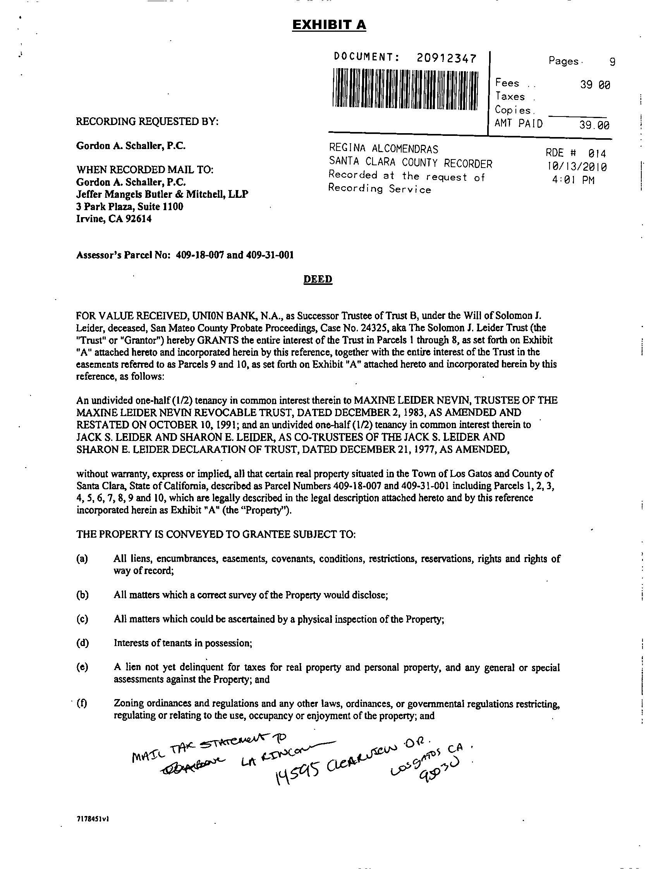

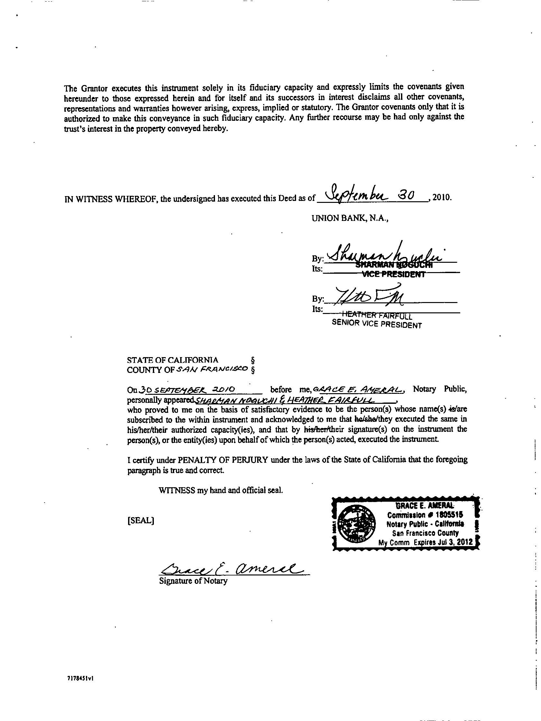

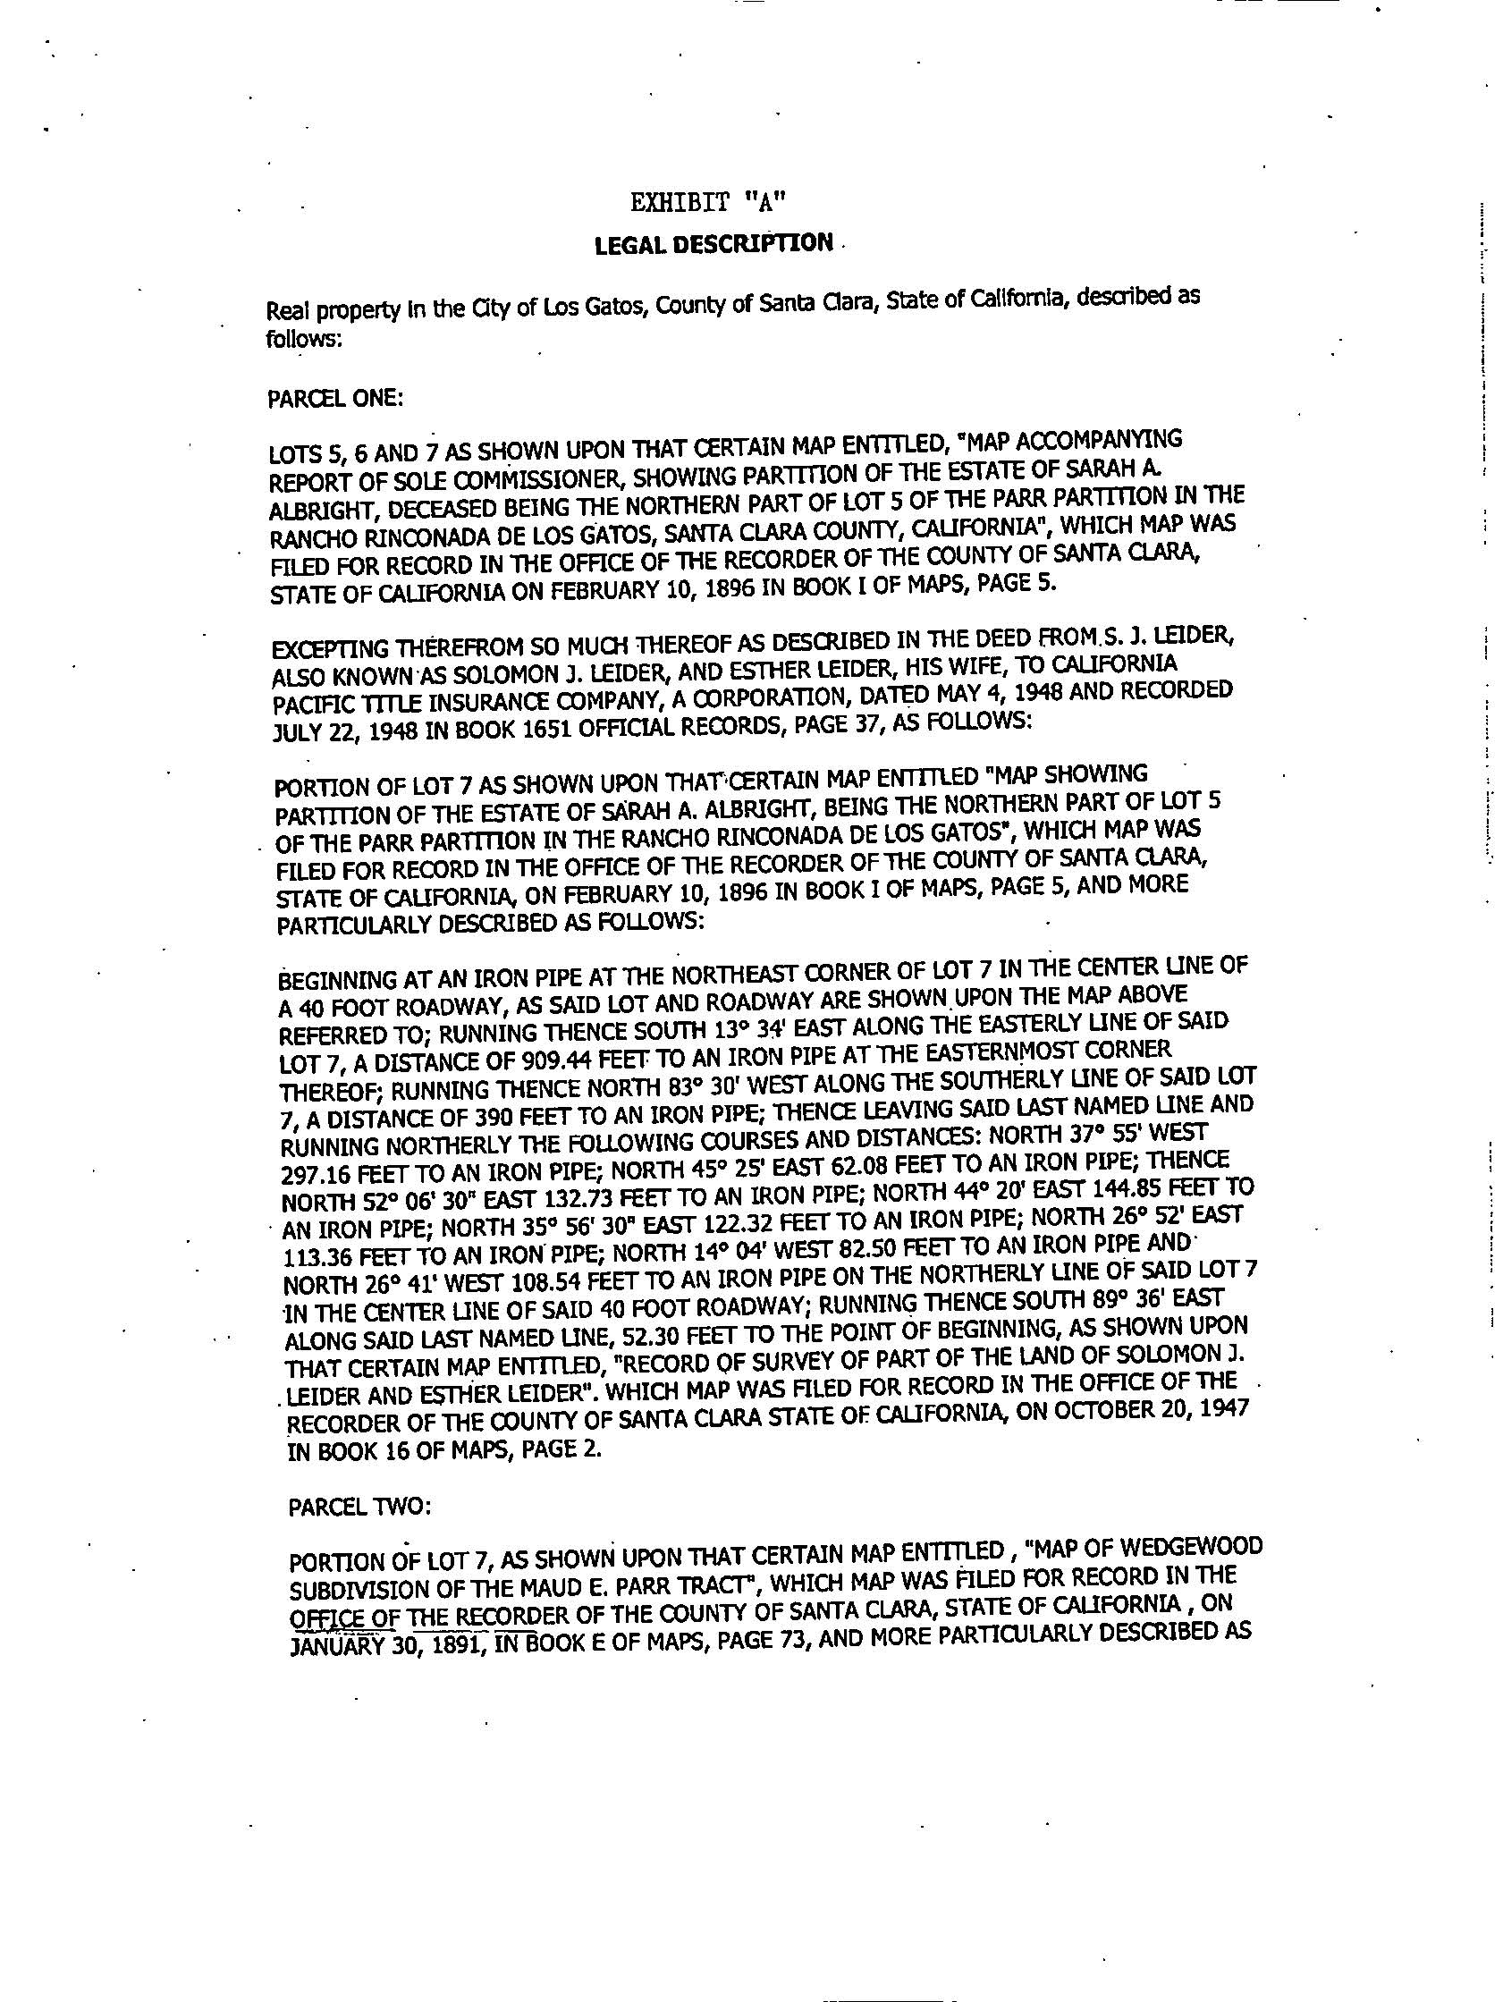

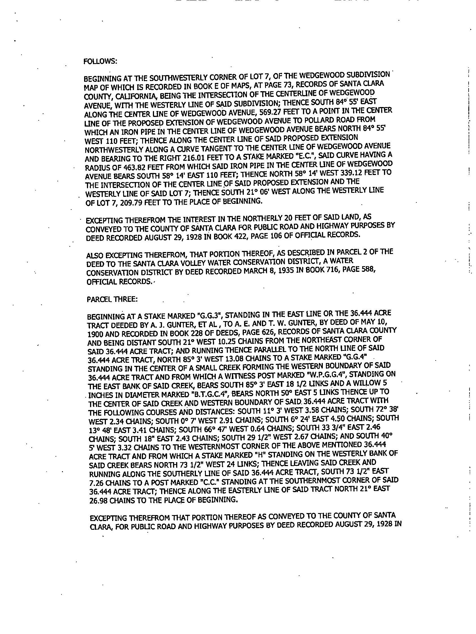

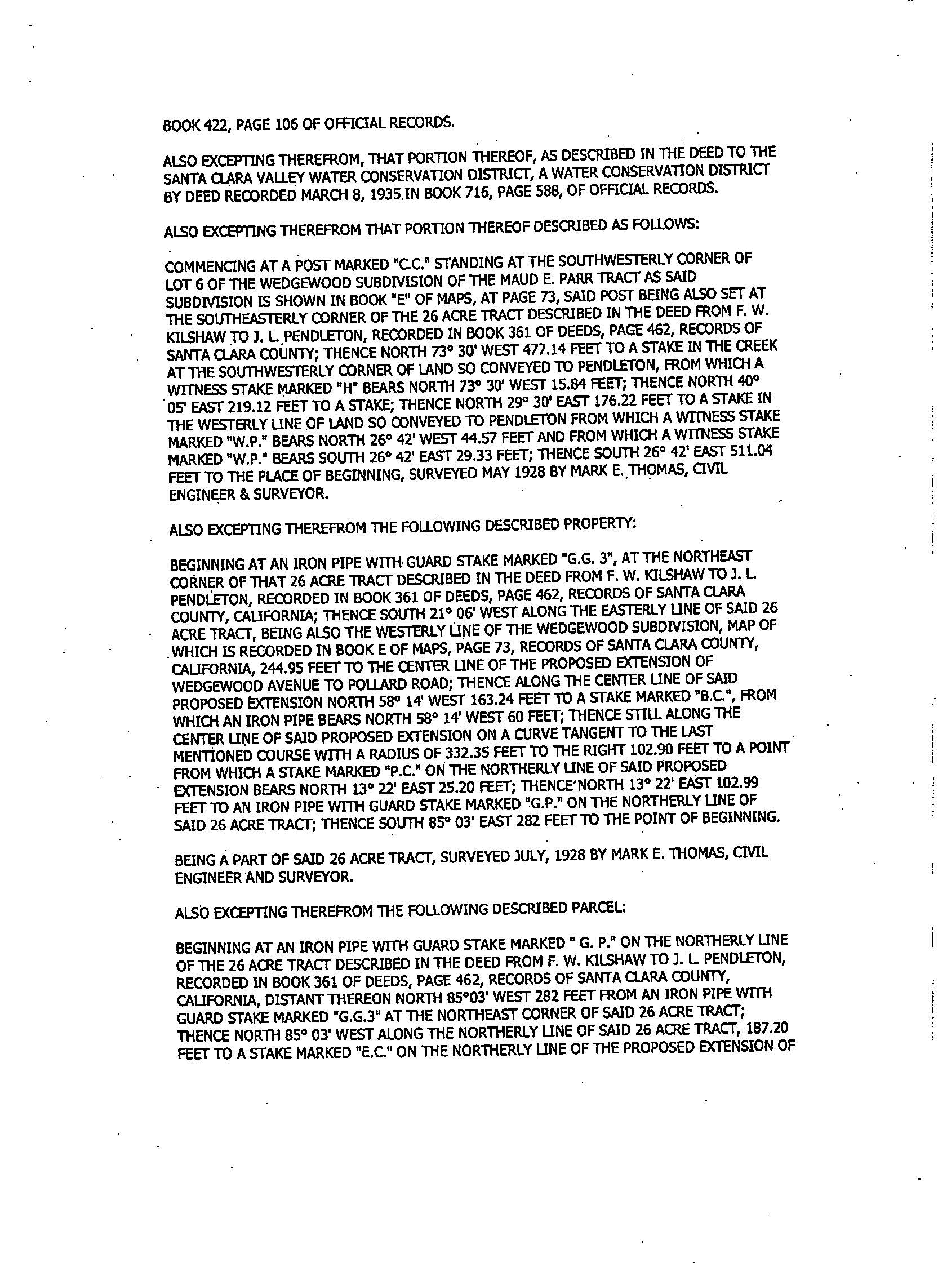

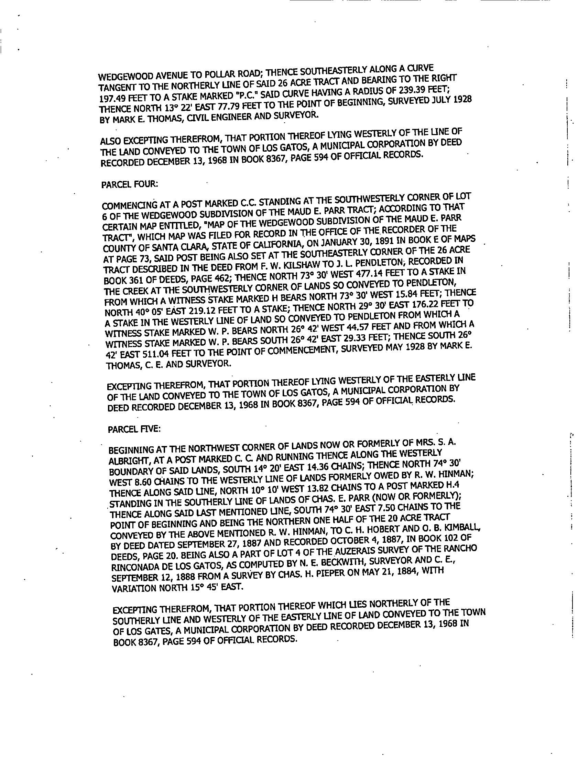

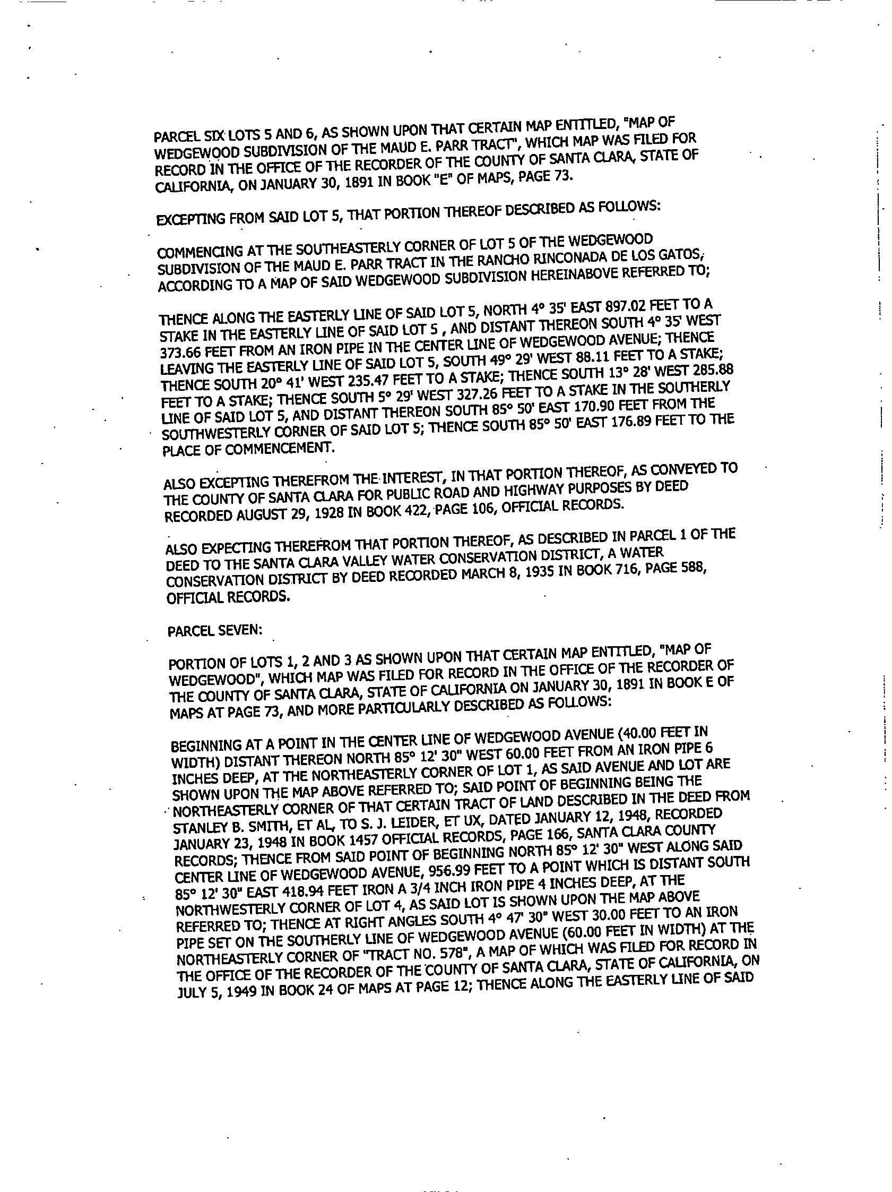

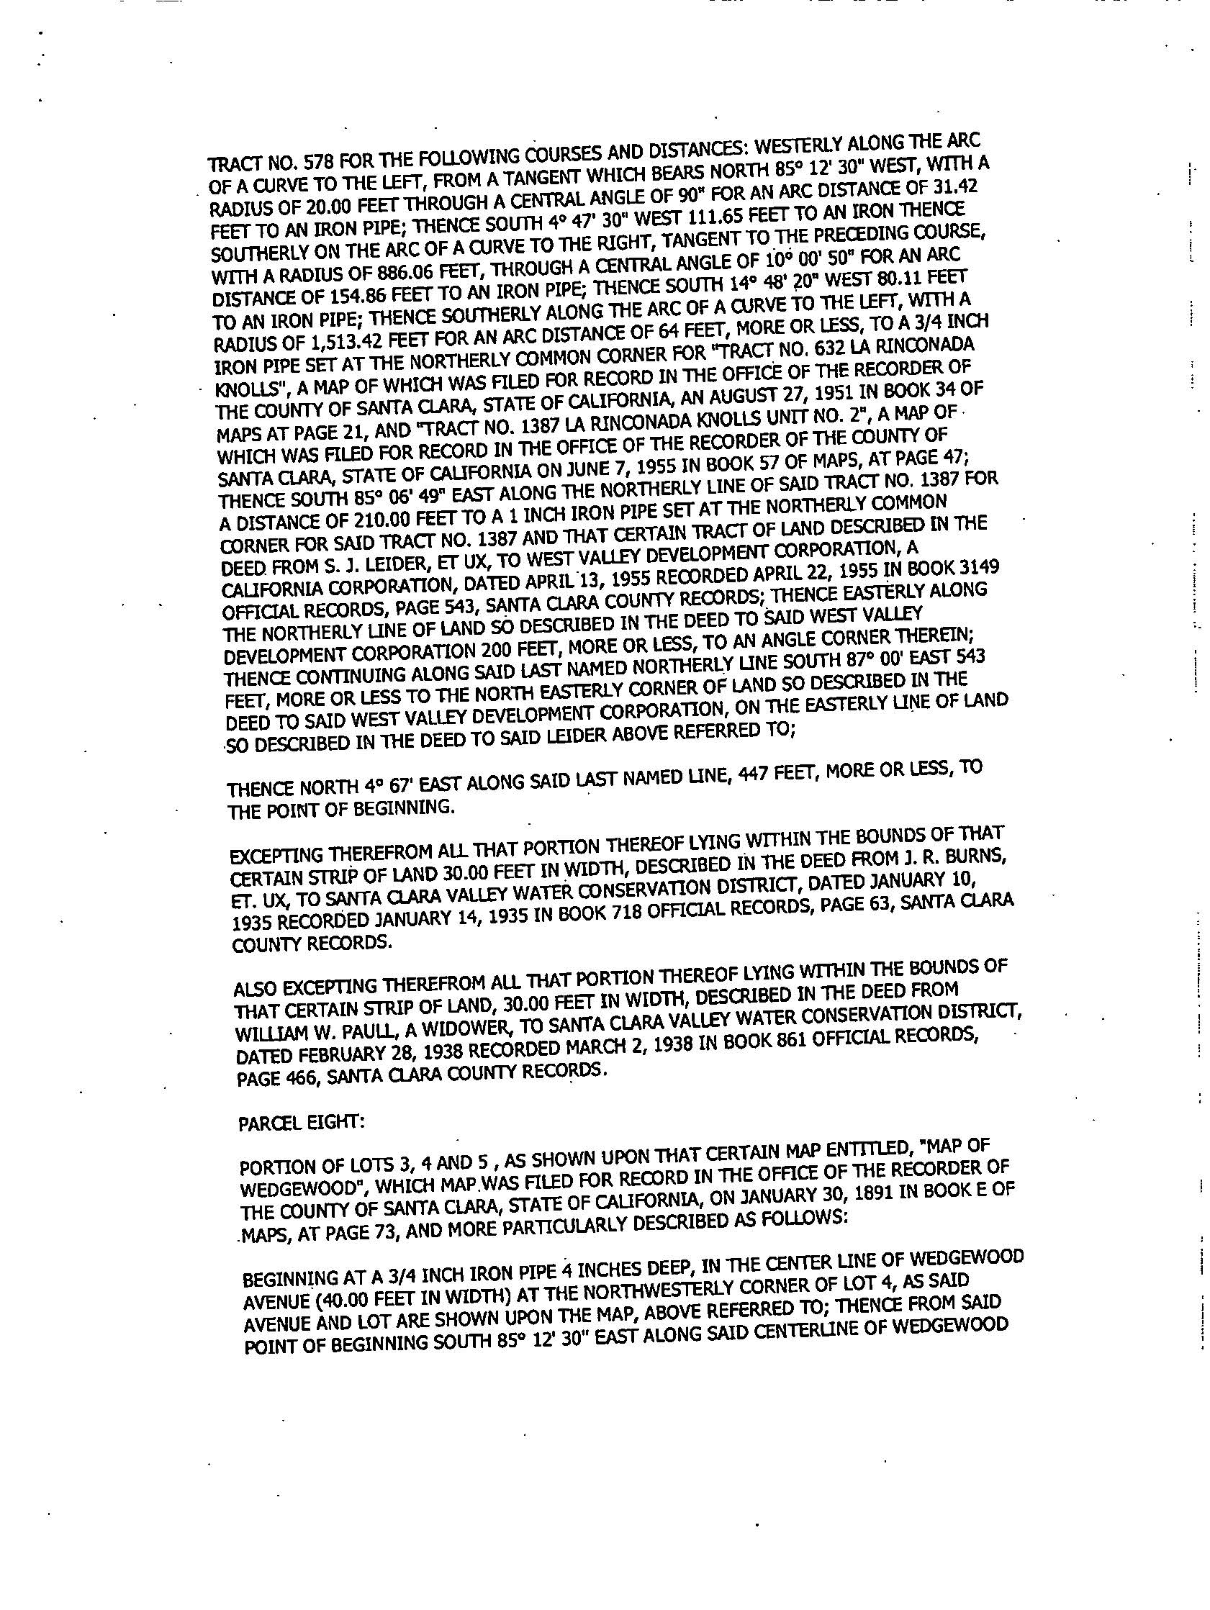

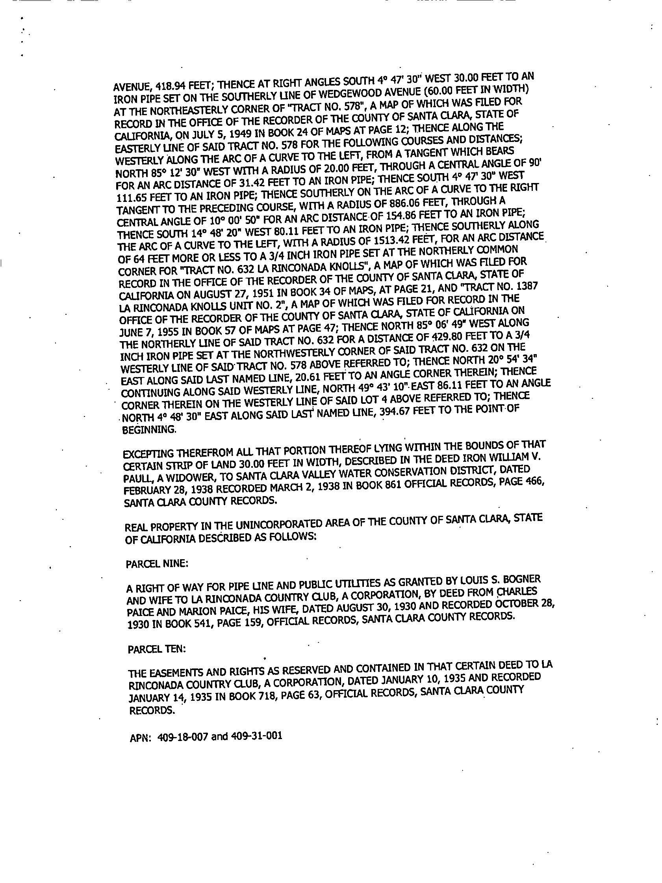

# Exhibit B

## INCENTIVES AND US TREASURY INFORMATION

American Recovery and Reinvestment Act of 2009 (2009 ARRA), P.L. 111-5, § 1603, as amended by the American Tax Relief Act of 2012 (2012 ATRA), P.L. 112-240, § 407(c)(2), effective retroactively to Feb. 17, 2009. 2012 ATRA § 407(d)(3).

*See* U.S. Treasury Dept., Office of the Fiscal Assistant Secretary, Payments for Specified Energy Property in Lieu of Tax Credits under the American Recovery and Reinvestment Act 2009 (rev. Jan. 2011) (the “Treasury Program Guidance”).

# EXHIBIT C

## SYSTEM DESCRIPTION WITH OUTPUTS

The Renewable Energy Property as presented herein and offered for Lease consists of 606, 300 Watt solar modules, various inverters and Balance of System Components to constitute a Turnkey solar generating facility. The total DC Watts is 181,800 kW.

Five hundred solar modules are proposed for installation at the Number 3 Fairway, as shown pictorially below.

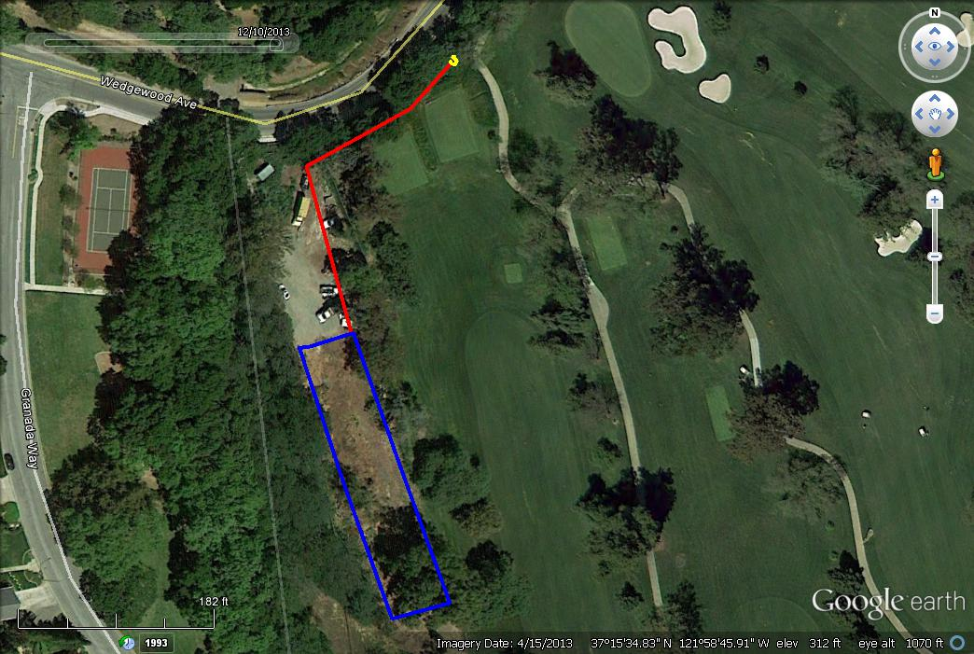

500 Solar Module Installation at #3 Fairway

The balance of the solar modules (106) are to be installed on previously constructed solar structures located at the Maintenance Yard facility, as shown below.

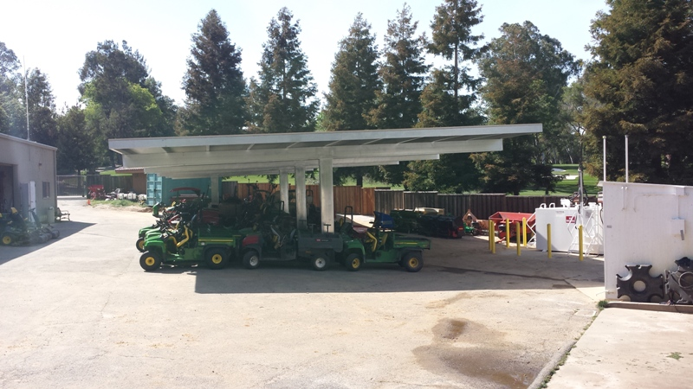

The solar generating facility is expected to generate approximately 252,488 kW-h/year covering approximately 35% of the Clubs electrical consumption.

# EXHIBIT D

## FINAL COMPLETION CERTIFICATE

Date:

La Rinconada Country Club

14595 Clearview Drive

Los Gatos, CA 95032

Attn: Stan Prolo

Re: FINAL COMPLETION CERTIFICATE

This certificate is issued pursuant to Section 4.2 of that certain Solar Power Equipment Lease Agreement (the “The Lease”), dated as of June_____________, 2014, by and between LA RINCONADA COUNTRY CLUB (Lessee) and ALTERNATIVE ENERGY COUNTRY CLUB SOLAR SOLUTIONS., a California LLC, (“Lessor”) Capitalized terms used but not defined herein have the meanings set forth in the Contract.

According to Section 4.2 of the Agreement, the following items are conditions precedent to Final Completion:

1. All punch list items have been completed or waived;
2. All manuals, drawings and other documents expressly required to be delivered by Contractor hereunder have been delivered to Client;
3. All final Lien waivers have been obtained;

The Contractor is certifying that all of the foregoing conditions of Final Completion have been satisfied.

Lessee shall, within ten (10) business days after the receipt by Lessee of this written certificate, execute the below acknowledgment if Lessor has achieved Final Completion. Execution of the below acknowledgment or failure of Lessee to provide written notice of Lessors failure to achieve Final Completion within ten (10) business days shall constitute acceptance of this Final Completion Certificate.

**DATE:**

|  |  |
| --- | --- |
| **“Lessee”**  ***LA RINCONADA COUNTRY CLUB*** | **“Lessor”**  **ALTERNATIVE ENERGY COUNTRY CLUB SOLAR SOLUTIONS LLC** |
| On Behalf Of: \LOBH6\ | By: \s8\ |
| Signature: \s6\ | Name: ______________\n8\ |
| Date: __________________\d6\ | Title: _______________ \t8\ |
|  | Date: ________________\d8\ |

# Exhibit E

## LIMITED WARRANTY AND PERFORMANCE GUIDELINES

THIS DOCUMENT DESCRIBES THE TERMS AND CONDITIONS OF THE LIMITED WARRANTY AND COVERING THE SOLAR SYSTEM INSTALLED AT LA RINCONADA COUNTRY CLUB, 14595 CLEARVIEW DRIVE, LOS GATOS, CA 95032, UNDER A CONTRACT WITH ALTERNATIVE ENERGY COUNTRY CLUB SOLAR SOLUTIONS LLC.

|  |  |  |
| --- | --- | --- |
| LESSOR: ALTERNATIVE ENERGY COUNTRY CLUB SOLAR SOLUTIONS LLC 5405 WILSHIRE BOULEVARD, LOS ANGELES, CALIFONEIA 90036 | | |
| PROPERTY OWNER:  *La Rinconada Country Club, Inc* | MAILING ADDRESS:  14595 Clearview Drive, Los Gatos, CA 95032 |  |

This limited warranty (this "***Limited Warranty***") is part of the Lease Agreement under which certain limited warranties are provided for the Solar System described in the aforementioned Agreement. In this Limited Warranty, the term "***Solar System***" means the solar power system to be installed by the "***Installer***" listed above on AEI CCSS’ behalf at the property at the installation address listed above (the "***Property***"). This Limited Warranty begins on the day installation begins.

This Limited Warranty refers to AEI COUNTRY CLUB SOLAR SOLUTIONS LLC, together with its successors and assigns, as "***AEI CCSS***" or "***we***" or "***us***".

This Limited Warranty refers to the property owner and any co-owner listed above, together with any permitted successors, heirs, and assigns, as "***Lessor***". Capitalized terms used but not defined have the meanings given to them in the Lease.

Under this Limited Warranty, the following limited warranties apply:

|  | Coverage | Term of Coverage |
| --- | --- | --- |
| **E1.**  **Limited Warranty on Installation and Use of Solar System** | AEI CCSS warrants the Solar System is of good quality, is new when installed, and is constructed and installed in a good workmanlike manner according to Prudent Solar Practices (as defined in Section 17 below). AEI CCSS also warrants the Solar System, under normal use and service conditions, against any defect or deficiency in workmanship. | The Term (as defined in Section 2(b) of the Lease) |
| **E2. Limited Warranty on Roofing Penetrations from Installation** | AEI CCSS warrants each roofing penetration made in connection with installing the Solar System, and the surrounding area within a five (5) inch radius of each penetration, against damage to the roof and against water infiltration through the roof.  AEI CCSS or its designee will repair the damage to the roof and the physical damage to your property from any resulting water infiltration. | For ten (10) years starting on the date we begin to install the Solar System. |
| **E3. Limited Warranty on Roofing Penetrations from Removal** | Should the Solar System be removed from the Property, AEI CCSS warrants the roofing repair work around each roofing penetration made in connection with installing the original Solar System, and the surrounding area within a five (5) inch radius of each penetration, against damage to the roof and against water infiltration through the roof. This warranty only applies if the Solar System is removed in accordance with Section 8 of the Lease.  AEI CCSS or its designee will repair the damage to the roof and the physical damage to your property from any resulting water infiltration. | For one (1) year starting on the date we begin to remove the Solar System from your Property. |
| **E4. Limited Warranty on Damage to Property and Belongings** | AEI CCSS warrants the Solar System and installation and repair work by us and our designated contractors against damage to the Property and belongings. | For the entire Term, starting on the day installation the Solar System begins. |

Internet Connection and Monitoring

Lessee agrees to allow AEI CCSS to monitor the Solar System (“the System Monitor”) and to connect to a cellular network compatible with the System Monitor (“Compatible Cellular Network”). If Lessee’s Property cannot be successfully connected by Installer to a Compatible Cellular Network, Lessee shall provide, at Lessee’s expense, a persistent internet connection.

If the System Monitor remains successfully connected to the internet through the connection, or if the System Monitor is able to connect to a Compatible Cellular Network, AEI CCSS will monitor the Solar System remotely at no additional cost. Additionally, AEI CCSS will promptly notify Lessee if, according to the monitoring information, the Solar System is not operating correctly. Lessee shall provide notification if the electricity or the internet connection described above will not be available for more than forty-eight (48) hours. If the electricity or internet connection described above fails for any period of time, AEI CCSS may estimate the power produced by the Solar System using reasonable means. If the Property location does not have Compatible Cellular Network coverage through the Term Lessee acknowledges and accepts that: AEI CCSS will be unable to properly monitor the Solar System

This Limited Warranty does not require AEI CCSS to perform or provide any of the excluded work described in Section 4.1 of the Lease.

The limited warranties set forth in this Limited Warranty are void and do not apply to reduced or lost electricity production or to repairs, improvements, corrections, or replacements of the Solar System required by or resulting from any of the following:

* 1. gross negligence or intentional damage to the Solar System, or a breach of, or failure of Lessee to perform, obligations under the Lease or this Limited Warranty;
  2. any actual or attempted installation, repair, alteration, replacement, or modification made by any person other than one of AEI CCSS’ designated contractors; or
  3. shading due to foliage or other obstacles that shade the Solar System more than the Solar System’s location was shaded on the date you signed the Lease.

AEI CCSS will not be in breach of this Limited Warranty because of any failure or delay in complying with its limited warranty, or other obligations under this Limited Warranty if such failure or delay is the result of Lessee’s failure to perform under the Lease or this Limited Warranty, including to provide AEI CCSS access to the Solar System, or is due to one or more events of Force Majeure (as defined below) or their effects. Additionally, the periods allowed for the performance by AEI CCSS of its obligations under this Limited Warranty shall be extended for so long as such Force Majeure events or effects continue. In order to claim relief due to Force Majeure, however, (i) AEI CCSS must provide prompt notice of the event of Force Majeure, to the extent reasonably practicable; (ii) the suspension of AEI CCSS’ performance must be of no greater duration and scope than that required by the event of Force Majeure; and (iii) AEI CCSS’ excused obligation must not be one which arose before the event of Force Majeure and which should have been fully performed before the event of Force Majeure occurred.

For purposes of this Agreement, the term "***Force Majeure***" means acts of God or the public enemy; war; hostilities; riots; terrorism; theft; any weather condition or actions of the elements; hurricane; flood; lightning; wind; drought; earthquakes; fires; floods; explosion; accidents; riots; strikes or other significant labor disputes; unavailability of electricity from the transmission grid; power or voltage surge caused by someone other than AEI CCSS or its representatives; unavailability or failure of equipment not utilized by or under the control of AEI CCSS or its representatives; the binding order of any governmental authority (provided that such order has been resisted in good faith by all reasonable legal means); the failure to act on the part of any governmental authority (provided that such action has been timely requested and diligently pursued); or any other causes, whether or not of the same class or kind as those specifically named above, which are not within the reasonable control of AEI CCSS or its representatives and which, by the exercise of reasonable diligence, AEI CCSS and its representatives are unable to prevent.

To ask a question regarding this Limited Warranty, call 1-800-854-9110 during normal business hours. To submit a claim or provide any other notice under this Limited Warranty, Lessee shall send a request in writing by email, fax, certified or registered first-class mail, post prepaid, with a return receipt requested, or a reputable courier service requiring signature for receipt.

To submit a claim or otherwise notify us by email, send an email to: cfrye@alternativeenergyinc.com, [bbach@alternativeenergyinc.com](mailto:bbach@alternativeenergyinc.com), or info@alternativeenergyinc.com

To submit a claim or otherwise notify Lessor by mail or courier, send the letter to:

AEI COUNTRY CLUB SOLAR SOLUTIONS LLC  
5405 WILSHIRE BOULEVARD, SUITE 335

LOS ANGELES, CALIFORNIA 90036

Attention: Warranty Claims

The parties agree that any faxed or emailed document shall be deemed an original document. All notices of arbitration must be sent by mail or courier, in the manner described above.

If AEI CCSSreceives a claim under this Limited Warranty, AEI CCSSwill review the claim and provide notification within five (5) business days whether the claim is covered by this Limited Warranty. If a determination cannot be made without inspecting the Solar System, AEI CCSSwill send an employee, contractor or agent to the Property within ten (10) business days of the date the claim is received, and will then provide a notification within five (5) business days of the visit as to whether the claim is covered by this Limited Warranty.

If the claim is covered by this Limited Warranty, then as required by Section 5, AEI CCSSwill make the repair or replacement within a reasonable period of time, at no cost to Lessee. AEI CCSSmay use new or reconditioned parts to make repairs. AEI CCSSwill use commercially reasonable efforts to replace parts with the same type of equipment, but we may substitute types of equipment if necessary.

The Solar System may only be moved by an AEI CCSS designated contractor, and only in order to permit a renovation or repair the Property at Lessee’s request and your expense. AEI CCSSwill send a contractor to provide a price quote for moving the Solar System. Lessee may then elect whether to have the contractor move the Solar System, at the quoted price. The price quote will be based on standard pricing terms that are on a time and materials basis.

This Limited Warranty only protects Lessee. If Lessee transfers all of your rights and obligations under the Lease to a buyer of the Property in a manner that is permitted by the Lease, then Lessee’s remaining rights and obligations under this Limited Warranty will automatically transfer to the buyer.

AEI CCSS may transfer, sell, or otherwise assign all or any of its rights and/or obligations under this Limited Warranty to another party, without Lessee consent and without prior notice. Any assignment of AEI CCSS’ obligations under this Limited Warranty will be to a party that is qualified to perform such obligations and that expressly accepts responsibility in writing for the obligations under this Limited Warranty. Upon such transfer, sale or assignment, AEI CCSS shall be released from all future obligations under this Limited Warranty.

If Lessee has a right under Section 8 of the Lease to require AEI CCSSto remove the Solar System, and if Lessee properly notifies AEI CCSS under this Limited Warranty and request that the Solar System be removed, then at no cost to you, AEI CCSSwill remove the Solar System and waterproof any roof penetrations that result from the removal.

The standards under this Limited Warranty will be applicable Prudent Solar Practices or as otherwise specified in this Limited Warranty. "Prudent Solar Practices" means those standards of care and diligence normally practiced by solar engineering, construction and installation firms in performing services of a similar nature in the same geographic region and in accordance with (i) good engineering design practices, (ii) applicable law (including local codes and standards), (iii) any applicable governmental approvals and permits, and (iv) any applicable requirements of the local utility. Each Solar System shall be constructed, installed, and repaired in a good workmanlike manner, using principles, criteria and standards generally accepted for use by a contractor in connection with residential photovoltaic solar power systems of a similar size and type as the Solar System.

LIMITED WARRANTY, EXCLUSIVE REMEDY. THE LIMITED ARE THE ONLY EXPRESS WARRANTIES AND GUARANTEES MADE BY AEI CCSS WITH RESPECT TO THE SOLAR SYSTEM AND ITS OPERATION. AEI CCSS HEREBY DISCLAIMS, LESSEE AND ALL OTHER BENEFICIARIES OF THIS LIMITED WARRANTY HEREBY WAIVE, ANY OTHER EXPRESS WARRANTY OR GUARANTEE WITH RESPECT TO THE SOLAR SYSTEM, ITS OPERATION, AND ANY COST SAVINGS FROM USING THE SOLAR SYSTEM. THE REPAIR, REPLACEMENT AND PAYMENT REMEDIES DESCRIBED UNDER THIS LIMITED WARRANTY ARE THE SOLE AND EXCLUSIVE REMEDIES FOR BREACH OF THIS LIMITED WARRANTY.

LIMITED DURATION OF IMPLIED WARRANTIES. ANY IMPLIED WARRANTIES ARISING UNDER STATE LAW, INCLUDING THE IMPLIED WARRANTIES OF FITNESS FOR A PARTICULAR PURPOSE, HABITABILITY, AND MERCHANTABILITY, SHALL IN NO EVENT EXTEND BEYOND THE END OF EXPRESS WARRANTIES DESCRIBED IN SECTION 5 ABOVE.

This Limited Warranty gives you specific legal rights, and you may also have other rights, which vary from state to state

This Limited Warranty is an exhibit to the Lease and is subject to all of the terms and conditions of the Lease. In the event of an express conflict between this Limited Warranty and the Lease, the terms of this Limited Warranty will control.

# EXHIBIT F

## LEASE PAYMENT; PURCHASE OPTION PRICE

1. **LEASE-TO-OWN PAYMENTS**

Lessor agrees to make four lease payment as set forth in the following table.

|  |  |  |
| --- | --- | --- |
| Payment Number | Trigger Event | Amount |
| Payment Number 1 | Upon Contract Signing | $65,000 |
| Payment Number 2 | Permit Acquisition | $175,000.00 |
| Payment Number 3 | Upon commencement of installation | $125,000.00 |
| Payment Number 4 | Upon Permit Sign-Off (final) | $125,000.00 |
| Payment Number 5 | Lease Commencement Date | Balance |

1. **EARLY PURCHASE OPTION**

Lessor may exercise the “Early ***Purchase Option Price***” as outlined below. The Early Purchase Option pricing as presented below is before any deduction and credits for payments already received by that time. For example, the Payment at the

|  |  |  |
| --- | --- | --- |
| End of Year |  | Amount |
| 1 |  | $630,000.00 |
| 2 |  | $607,500.00 |
| 3 |  | $585,000.00 |
| 4 |  | $562,500.00 |
| 5 |  | $542,000.00 |

# Exhibit G

## OWNERSHIP OF ENVIRONMENTAL ATTRIBUTES AND INCENTIVES

As discussed in Section 6 of the Lease, the Environmental Attributes and Environmental Incentives with respect to the Solar System are owned as indicated by the checked box(es) below:

* All Environmental Attributes and Incentives are the sole property of Lessor; or
* The Environmental Attributes and Incentives described below are the property of Customer (“Customer’s Incentives”) and all Environmental Attributes and Incentives not described below (“Other Incentives”) are the sole property of AEI CCSS.
  + N/A